VSCode
Installation

Table of Contents

Overview 3
Installation 4
Configuration 8

Overview

This document describes how to install and configure VSCode.

Installation

- Execute the following:
VSCode_Install_64bit.exe
Execution requires ‘Administrator’ privileges. If the current operating system user does not possess these privileges, the operating system will display the ‘User Account Control’ authorization dialog window.

- The following window will be displayed:
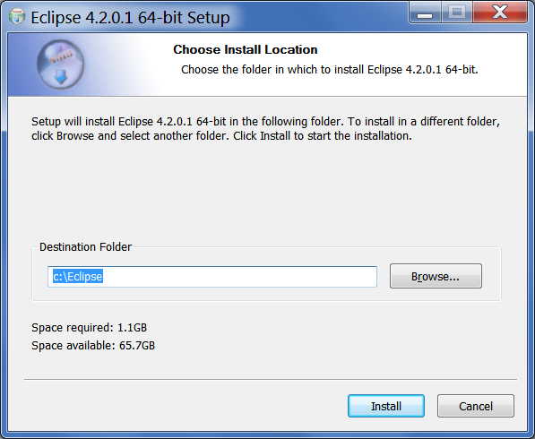
Press the ‘Install’ button.

- The application will begin copying files to the destination folder. The window will appear as follows:
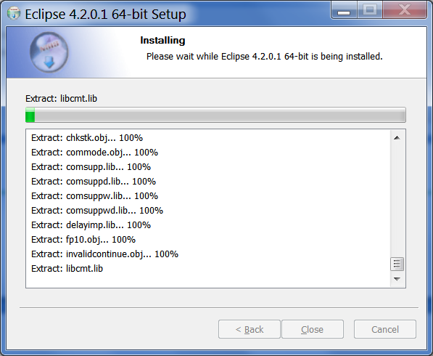

- When all files have been copied, the following window will be displayed:
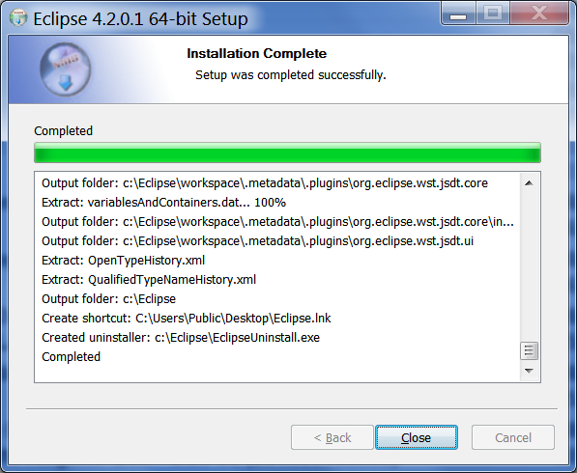
Press the ‘Close’ button.
That completes the installation.

Configuration

- Start the application.
That completes the configuration.

